# Import necessary libraries

import numpy as np

import matplotlib.pyplot as plt

from tensorflow.keras import datasets, layers, models

from tensorflow.keras.utils import to_categorical

from sklearn.model_selection import train_test_split

# Load the MNIST dataset

(train_images, train_labels), (test_images, test_labels) = datasets.mnist.load_data()

# Preprocess the data

# Reshape images to 28x28x1 (grayscale)

train_images = train_images.reshape((train_images.shape[0], 28, 28, 1))

test_images = test_images.reshape((test_images.shape[0], 28, 28, 1))

# Normalize the pixel values to be between 0 and 1

train_images, test_images = train_images / 255.0, test_images / 255.0

# Convert labels to one-hot encoding

train_labels = to_categorical(train_labels, 10)

test_labels = to_categorical(test_labels, 10)

# Define the CNN model

model = models.Sequential([

layers.Conv2D(32, (3, 3), activation='relu', input_shape=(28, 28, 1)),

layers.MaxPooling2D((2, 2)),

layers.Conv2D(64, (3, 3), activation='relu'),

layers.MaxPooling2D((2, 2)),

layers.Conv2D(64, (3, 3), activation='relu'),

layers.Flatten(),

layers.Dense(64, activation='relu'),

layers.Dense(10, activation='softmax') # 10 classes for 0-9 digits

])

# Compile the model

model.compile(optimizer='adam',

loss='categorical_crossentropy',

metrics=['accuracy'])

# Train the model

history = model.fit(train_images, train_labels, epochs=5, batch_size=64, validation_split=0.1)

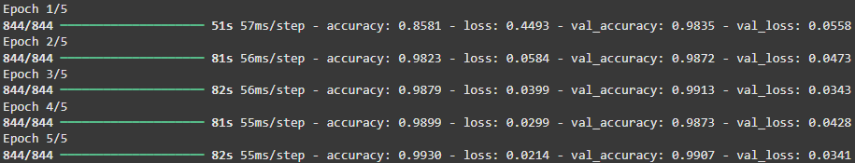

# Evaluate the model on the test set

test_loss, test_acc = model.evaluate(test_images, test_labels)

print(f"Test accuracy: {test_acc * 100:.2f}%")



# Save the model (optional)

model.save('mnist_cnn_model.h5')

# Plot the training history (optional)

plt.plot(history.history['accuracy'], label='accuracy')

plt.plot(history.history['val_accuracy'], label = 'val_accuracy')

plt.xlabel('Epochs')

plt.ylabel('Accuracy')

plt.ylim([0, 1])

plt.legend(loc='lower right')

plt.show()

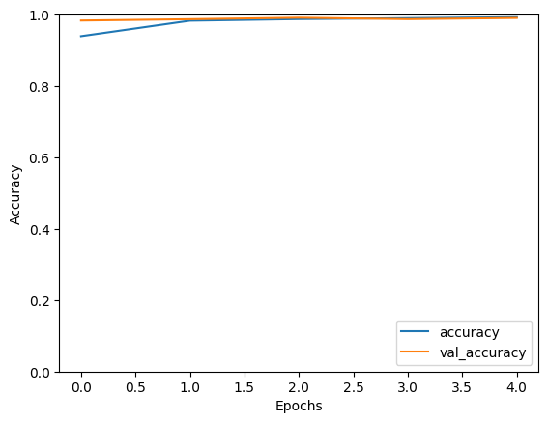

# Predictions (optional)

predictions = model.predict(test_images[:5])



# Show the predicted digits and the actual digits

for i in range(5):

plt.imshow(test_images[i].reshape(28, 28), cmap='gray')

plt.title(f"Predicted: {np.argmax(predictions[i])}, Actual: {np.argmax(test_labels[i])}")

plt.show()

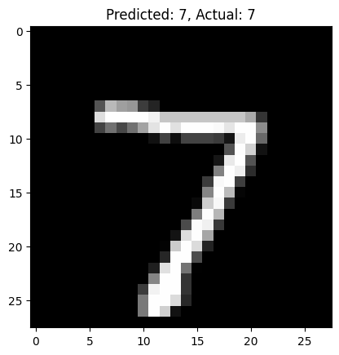

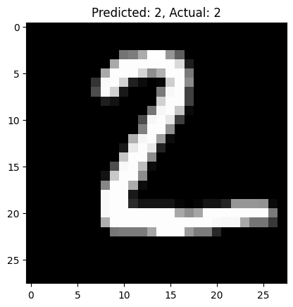

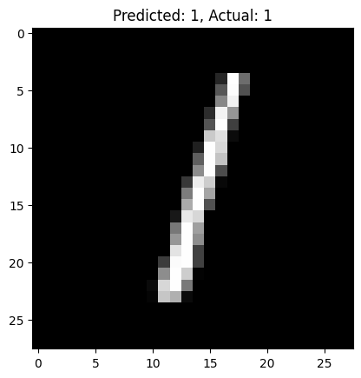

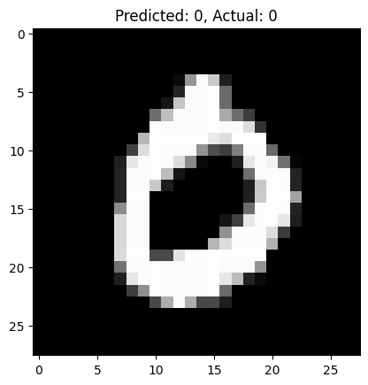

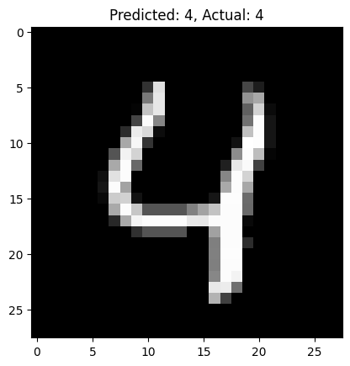

GOOGLE COLAB PROJECT LINK:

<https://colab.research.google.com/drive/1olnBH-v61GZBslZvkdY6HZ_1MjHDbGta>